
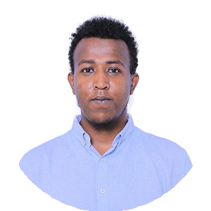
CONTACT
natyyosefadisu@gmail.com 0965767512
www.linkedin.com/in/natinael-yosef https://github.com/natinaelyosef
EDUCATİON
Bachelor of Science in Computer Science
Institution: Adama Science and Technology University
Year of Graduation: 2025
CERTİFİCATES
→Programming Fundamentals from 5 Million Ethiopian Coders
→ASTU Member of the Peace Forum
→ASTU Carity Club
→ASTU Student Saftey and Deslipline

Natinael Yosef Adisu
Software Engineer

SKİLLS
→Front-end Development ,Back-end Development.Database Managment,API Development & Integration,Version Control and Problem Solving

→I am a full-stack developer skilled in both front-end and back-end development. I build responsive and user- friendly interfaces using HTML, CSS, JavaScript, React, and Tailwind CSS. On the back end, I work with Python frameworks like FastAPI and Flask, as well as Laravel in PHP to develop secure and scalable web applications. I have experience managing databases such as PostgreSQL, MySQL, and SQLite, and I am comfortable writing complex queries and ensuring data integrity. I also specialize in API development and integration using RESTful services, JSON, and authentication methods like JWT and OAuth. For version control, I use Git and GitHub. I enjoy solving problems, debugging code, and working in agile environments using tools like Trello to stay organized and collaborative.

COURSES
→Agile and Test Driven Development
→Blockchain and Crytocurrency
→Computer Systems Security
→Database Systems
→Data Structures & Algorithms
→Data Commnucation & Computer Development
→Operating Systems
→Website Development

